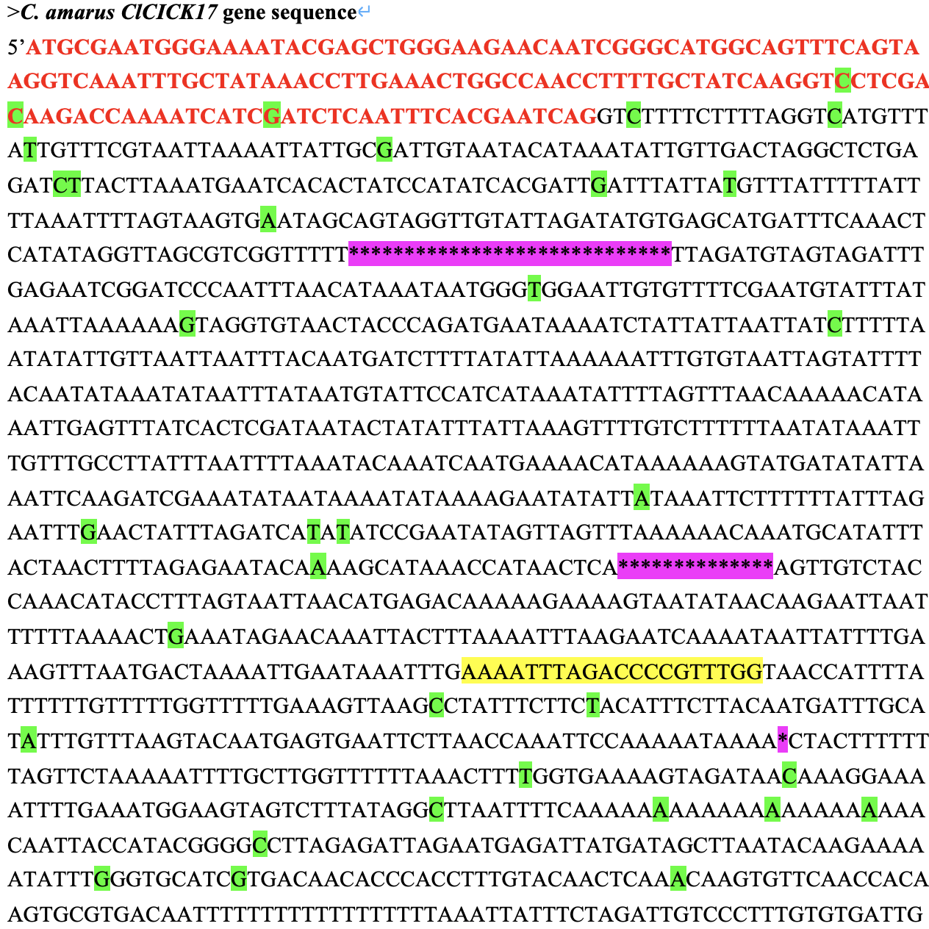
exon1
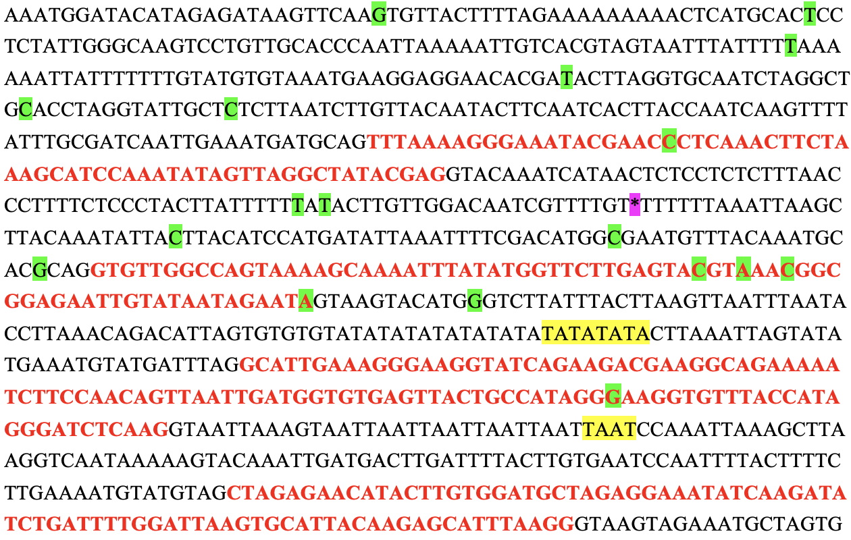
Exon2
Exon4
Exon3
Exon5
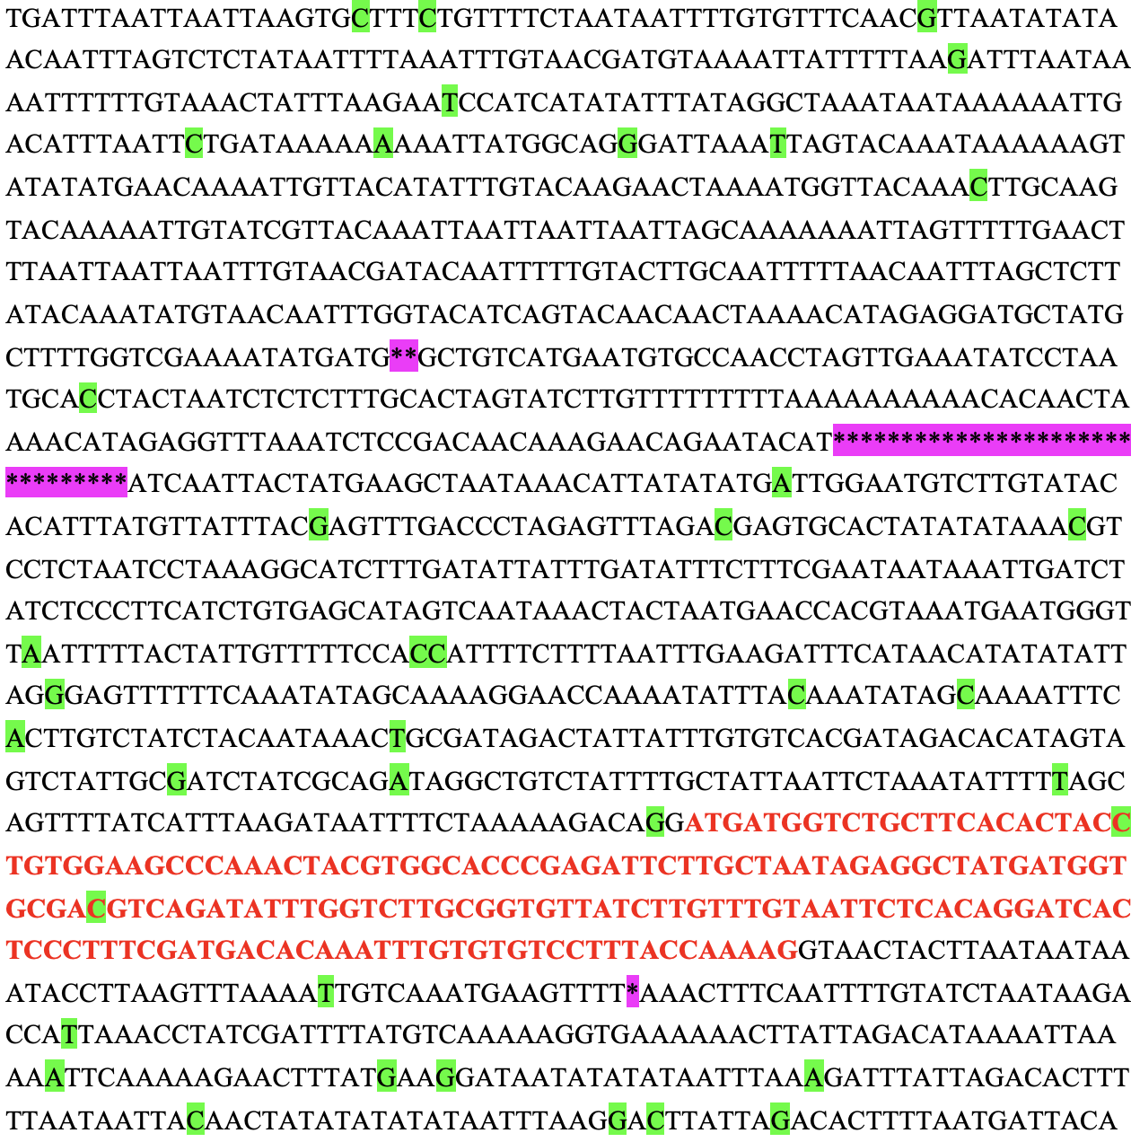
Exon6
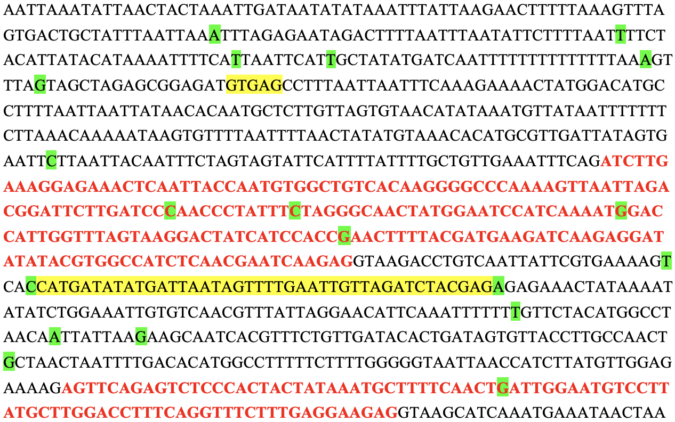
Exon7
Exon8
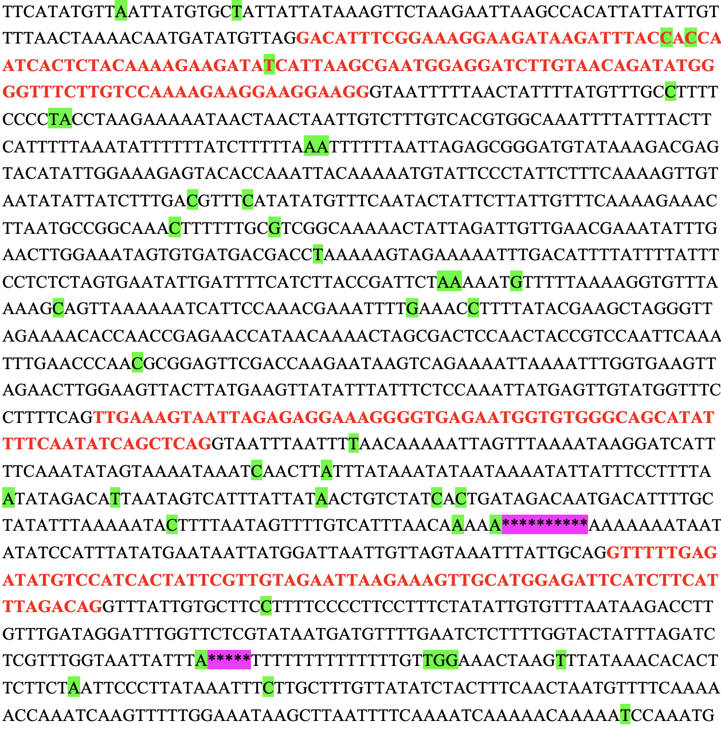
Exon10
Exon9
Exon11
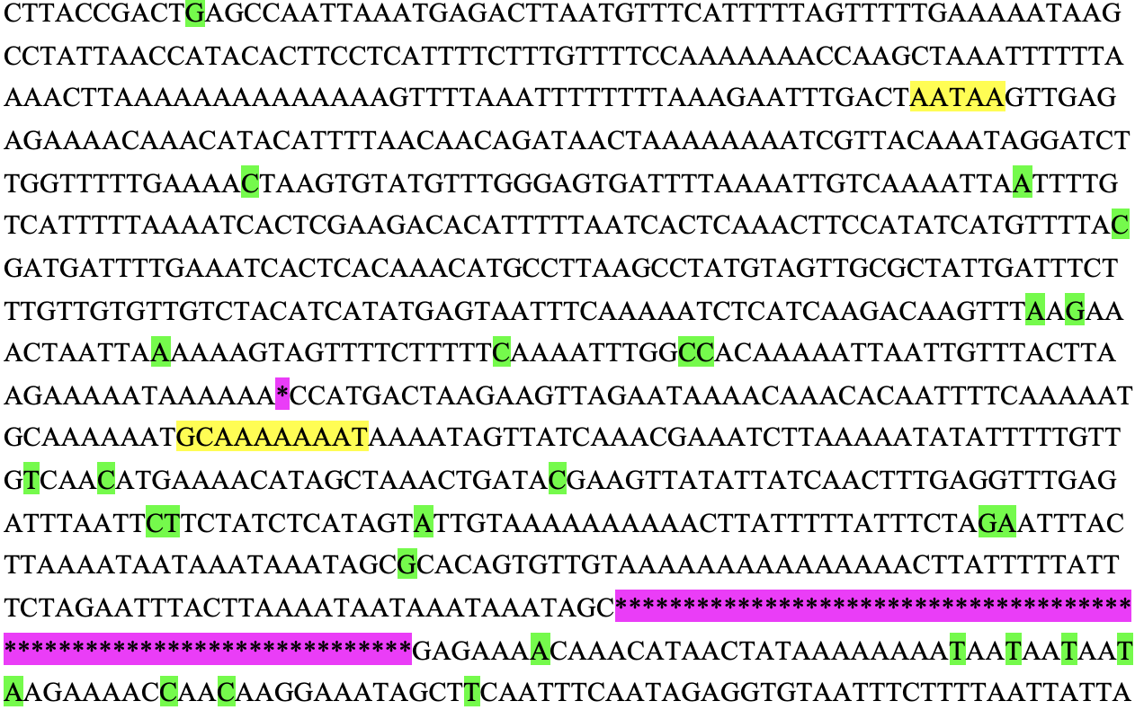
Exon12
Fig. S1 C. amarus ClCIPK17 gene sequence information. Red letters, exon; black letters, intron; green background, base mutation; yellow background, base insertion; pink background, base deletion.

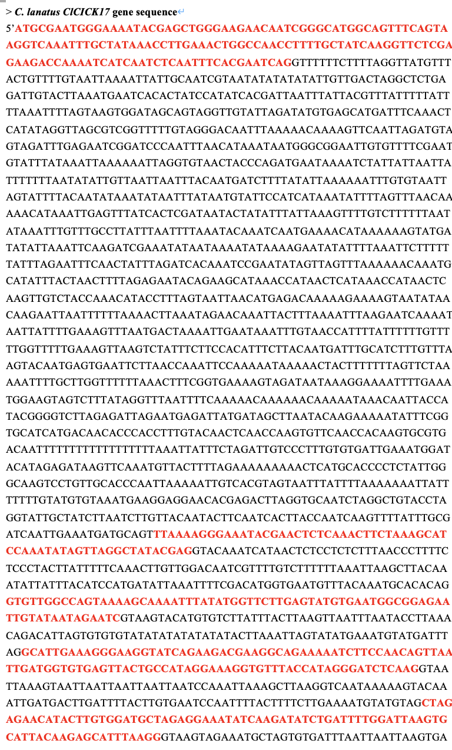
Exon1
Exon5
Exon2
Exon3
Exon4
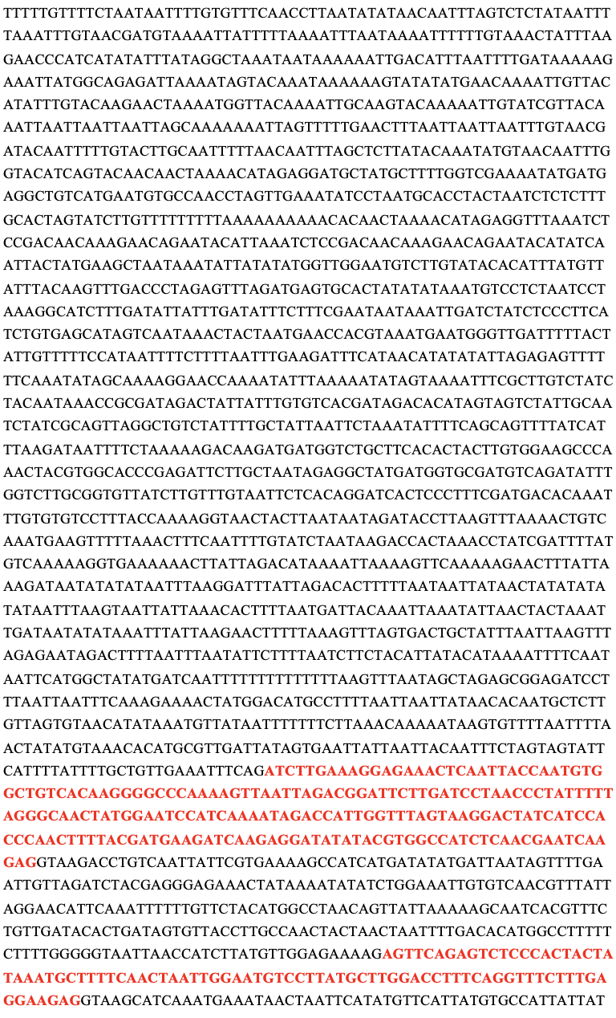
Exon7
Exon6
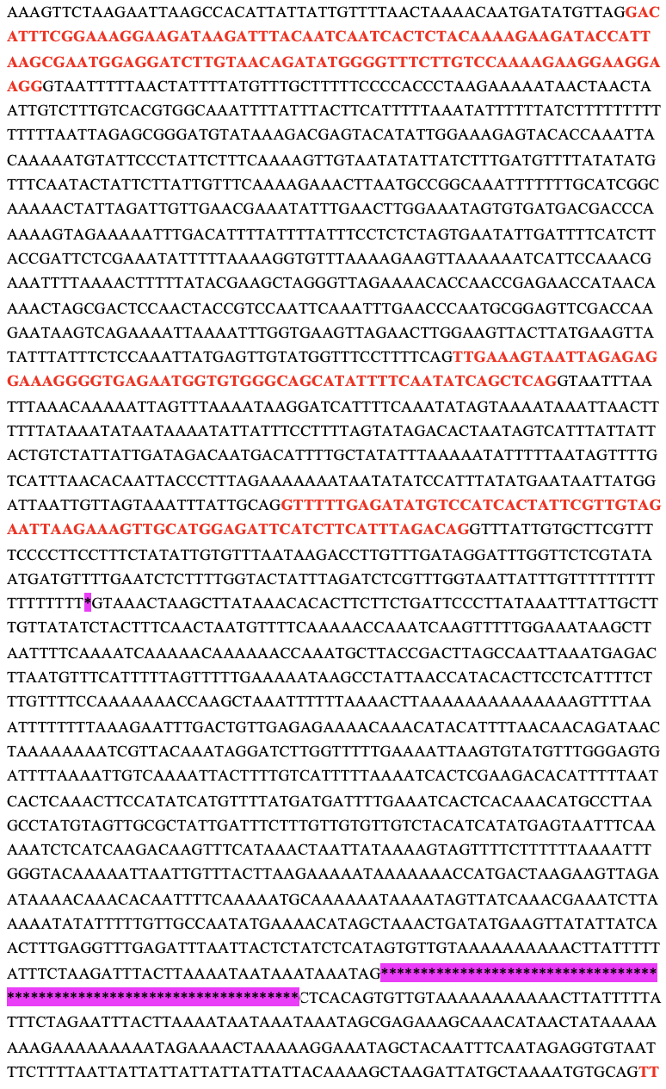
Exon10
Exon8
Exon9
Exon11
Fig. S2 C. lanatus ClCIPK17 gene sequence information. Red letters, exon; black letters, intron; pink background, base deletion.

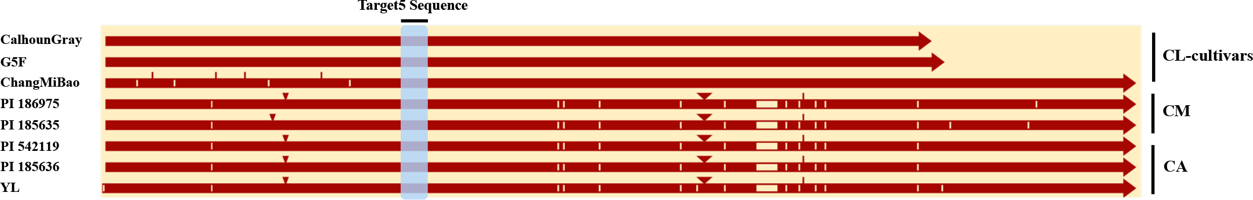
Fig. S3 Analysis of mutations at sgRNA5 in different watermelon accessions. In the gene diagrams, light blue block, brown triangles, white bars and red bars indicate target sequences, base insertion, SNP variation and insertion mutations, respectively.
Fig. S4 Sequencing analysis of mutation types at the sgRNA1 target site. (A) Insertion; (B) Small fragment deletion; (C) Large fragment deletion; (D) Insertion & deletion. Yellow background, base insertion；-, base deletion; —, base omitting.

